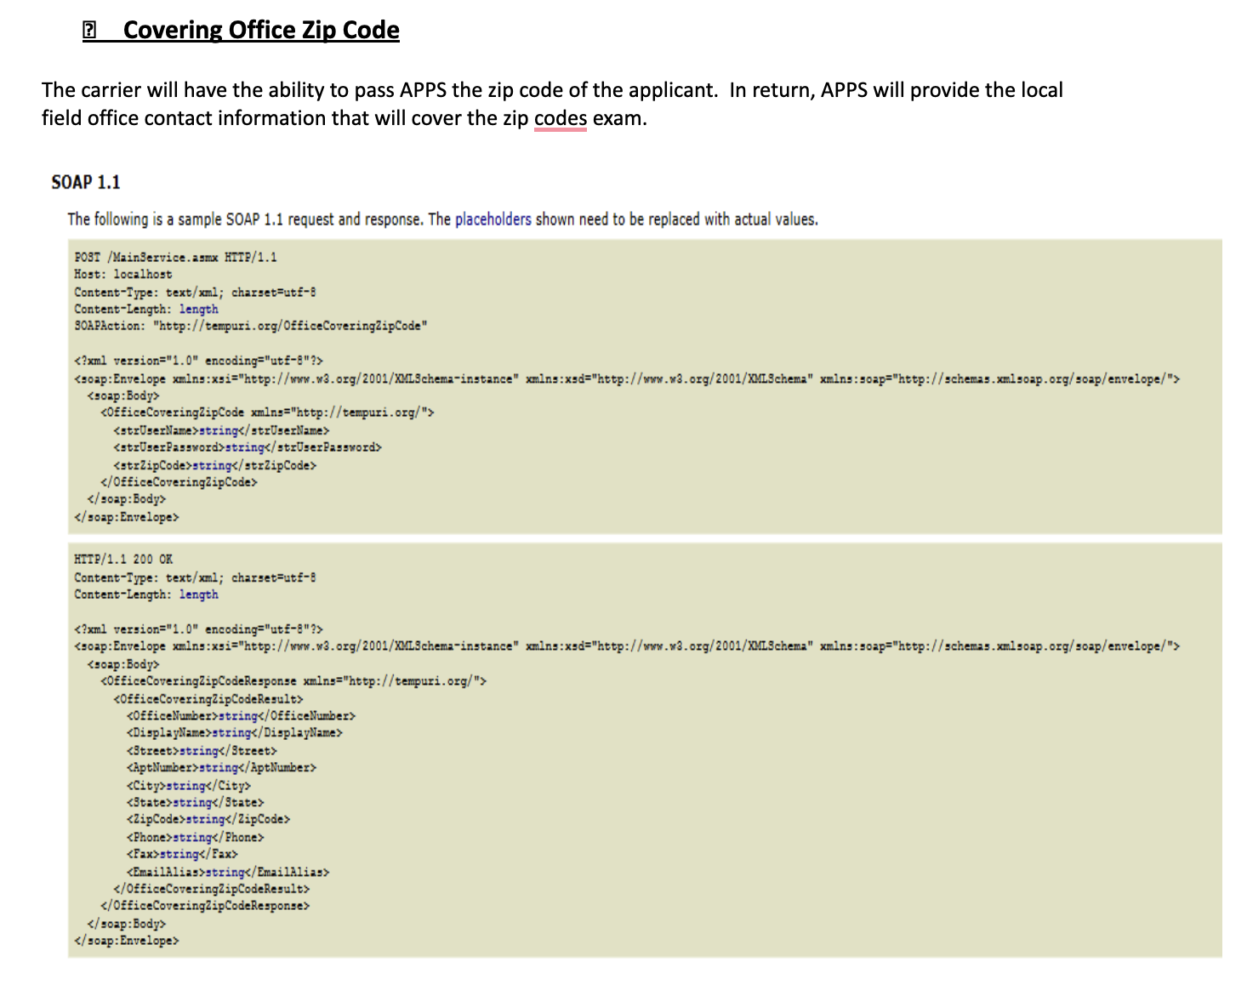
Covering Office Zip Code
The carrier will have the ability to pass APPS the zip code of the applicant. In return, APPS will provide the local field office contact information that will cover the zip codes exam.
SOAP 1.1
The following is a sample SOAP 1.1 request and response. The placeholders shown need to be replaced with actual values.
POST /MainService.asmx HTTP/1.1
Host: localhost
Content-Type: text/xml; charset=utf-8
Content-Length: length
SOAPAction: "http://tempuri.org/OfficeCoveringZipCode"
<?xml version="1.0" encoding="utf-8"?>
<soap:Envelope xmlns:xsi="http://www.w3.org/2001/XMLSchema-instance" xmlns:xsd="http://www.w3.org/2001/XMLSchema" xmlns:soap="http://schemas.xmlsoap.org/soap/envelope/"> <soap:Body>
<OfficeCoveringZipCode xmlns="http://tempuri.org/">
<strUserName>string</strUserName>
<strUserPassword>string</strUserPassword>
<strZipCode>string</strZipCode>
</OfficeCoveringZipCode>
</soap:Body>
</soap:Envelope>
HTTP/1.1 200 OK
Content-Type: text/xml; charset=utf-8
Content-Length: length
<?xml version="1.0" encoding="utf-8"?>
<soap:Envelope xmlns:xsi="http://www.w3.org/2001/XMLSchema-instance" xmlns:xsd="http://www.w3.org/2001/XMLSchema" xmlns:soap="http://schemas.xmlsoap.org/soap/envelope/"> <soap:Body>
<OfficeCoveringZipCodeResponse xmlns="http://tempuri.org/">
<OfficeCoveringZipCodeResult>
<OfficeNumber>string</OfficeNumber>
<DisplayName>string</DisplayName>
<Street>string</Street>
<AptNumber>string</AptNumber>
<City>string</City>
<State>string</State>
<ZipCode>string</ZipCode>
<Phone>string</Phone>
<Fax>string</Fax>
<EmailAlias>string</EmailAlias>
</OfficeCoveringZipCodeResult>
</OfficeCoveringZipCodeResponse>
</soap:Body> </soap:Envelope>

